https://www.jdoodle.com/embed/v0/69RG
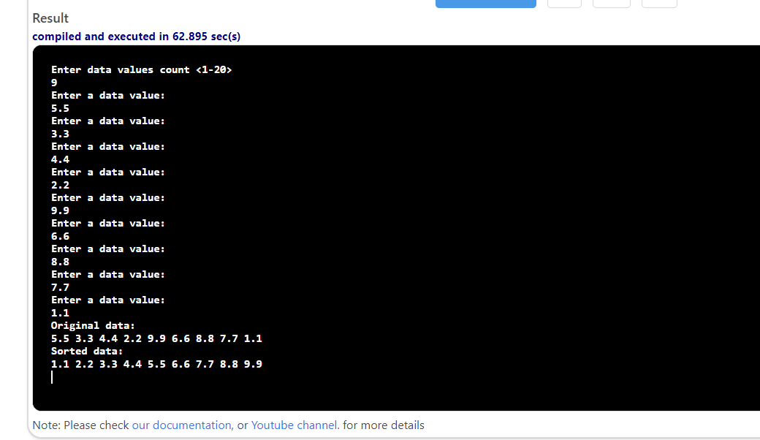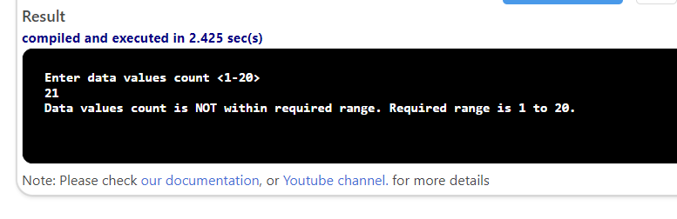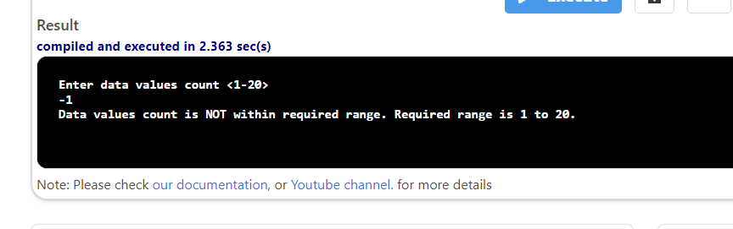

#include <iostream>
using namespace std;

void input(double x[], int length);
void copy(double source[], double dest[], int length);
void sort(double x[], int length);
void display(double x[], int length);

int main()
{
int length;
double data[20];
double sdata[20];

cout << "Enter data values count <1-20>" << endl;
cin >> length;

if (length < 1 || length > 20)
{
cout << "Data values count is NOT within required range. Required range is 1 to 20." << endl;
return 0;
}

input(data, length);
copy(data, sdata, length);
sort(sdata, length);

cout << "Original data:" << endl;
display(data, length);

cout << "Sorted data:" << endl;
display(sdata, length);
return 0;
}

void input(double x[], int length)
{
for (int i = 0; i < length; i++)

{
cout << "Enter a data value:" << endl;
cin >> x[i];
}

}

void copy(double source[], double dest[], int length)
{
for (int i = 0; i < length; i++)

{
dest[i] = source[i];
}

}

void sort(double x[], int length)
{
for (int i = 0; i < length - 1; i++)

{
for (int j = 0; j < length - i - 1; j++)

{
if (x[j] > x[j + 1])

{
double temp = x[j];
x[j] = x[j + 1];
x[j + 1] = temp;
}
}
}
}

void display(double x[], int length)
{
for (int i = 0; i < length; i++)

{
cout << x[i] << " ";
}

cout << endl;
}

